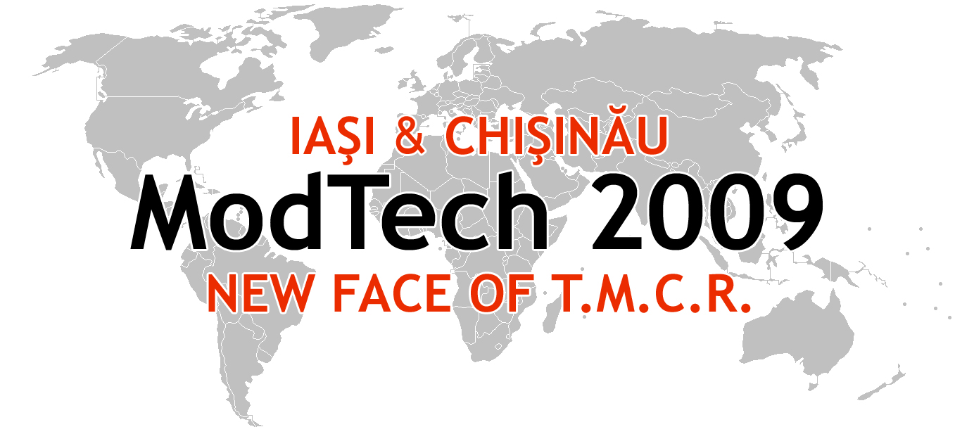

ModTech International Conference - New face of TMCR
Modern Technologies, Quality and Innovation - New face of TMCR
21-23rd May 2009
http://www.modtech.ro

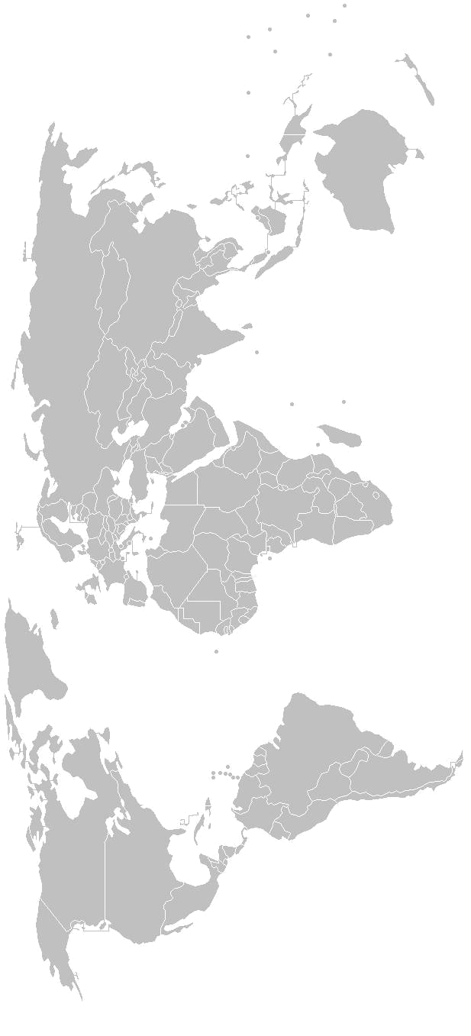
SECTION 7
Welding and Non-Conventional Technologies

B-0-12, Laboratory of Non-Conventional Technologies

Chair: Assoc. Prof. Laurentiu Ghenghea, Ph.D.
Co-chair: Assoc. Prof. Oana Dodun, Ph.D.
Secretary: Lacramioara Apetrei, Ph.D. Student

Thursday  May 21 | Papers & Authors
15²⁰-15³⁵ | Machinability by electrochemical discharge machining  Margareta Coteaţă, Antonio Mourao, Nicolae Pop & Ciprian Ciofu
15³⁵-15⁵⁰ | The influence of entrance parameters above the aluminium ultrasonic welding resistance  Apetrei L., Oanca O., Toma C., Sirbu A., Munteanu A.
15⁵⁰-16⁰⁵ | Modular device for manufacturing of the 800 w magnetron anodic bodies by means of electric discharge machining  Traian Buidoş, Florin Blaga
16⁰⁵-16²⁰ | Assembling of the 800w magnetron anodic body by brazing into a controlled atmoshere oven  Traian Buidoş, Mircea-Petru Ursu, Iulian Stănăşel
16²⁰-16³⁵ | Friction stir welding of Al 6082 alloy  Radu Cojocaru, Dorin Dehelean, Ramona Gabor, Cristian Ciucă & Uros Zupanc
16³⁵-16⁵⁰ | Non-conventional heating equipments used for liquid food pasteurization with microwave energy  Andreea-Manuela Constantin, Laurentiu Emanuel Zelenyak
16⁵⁰-17⁰⁵ | Connection between preheating temperature and current in welding process  Dan Ghenghea
17⁰⁵-17²⁰ | Experimental study for determination of the fracture mechanics parameters at welded steel bridges in use  Anca Gido
17²⁰-17³⁵ | Investigation of the effects of plasma cutting parameters on the roughness variation of some mild steel plates  Sanda-Maria Ilii, Dragoş Achiţei & Adriana Munteanu
17³⁵-17⁵⁰ | Case study of heat transfer processes in flax and hemp melting tanks using geothermal water  Liliana Indrie, Sabina Gherghel, Mariana Prichici & Ioan Almăşan
17⁵⁰-18⁰⁵ | Electrical discharge machining performance of aluminum hybrid composite material Adrian Iosub & Florin Negoescu
18⁰⁵-18²⁰ | Copper biorecovery from electronic scrap using ultrasound  Ivănuş Radu Cristian
Friday  May 22 | Papers & Authors
9⁰⁰-9¹⁵ | Particularities of the execution technologies ion plasma vaporations coating tools Aleksander Mikhaylov, Abdul-Jaleel H. Majeed, Elena Mikhaylova, Aleksander Nedashkovskiy, Navka Ilija
9¹⁵-9³⁰ | The microhardness variation of the welding bead in case of the electron beam welding  Adriana Munteanu, Dragoş Achitei
9³⁰-9⁴⁵ | Theoretical aspects regarding the vibrations reducing of the machines tools with a nonconventional materials structure  Loredana Paun, Valeriu Avramescu, Stefan Craciunoiu, Nicolae Predincea
9⁴⁵-10⁰⁰ | Some considerations concerning the abrasive jet machining  Ştefan Potârniche, Laurenţiu Slătineanu, António Gonçalves-Coelho, Vasile Focşa, Margareta Coteaţă
10⁰⁰-10¹⁵ | Some phenomenological aspects at the ultrasonic machining  Laurenţiu Slătineanu, Loredana Santo, Oana Dodun, Dumitru Uliuliuc & Lăcrămioara Apetrei
10¹⁵-10³⁰ | Hardware approach to electrical discharge machining monitoring  Cristian-Gheorghe Turc & Eugen Pămîntas
10³⁰-10⁴⁵ | Software approach to electrical discharge machining monitoring  Cristian-Gheorghe Turc & George Belgiu
10⁴⁵-11⁰⁰ | Operating parameters at the electrical discharge machining  Uliuliuc Dumitru & Rădeanu Alexandru

